**Ophthalmology training- additional material**

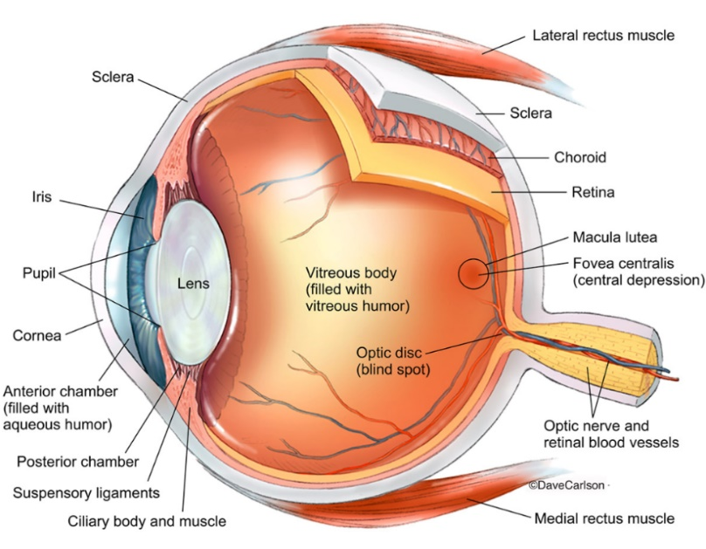**Anatomy of the eye**

**Anterior chamber**- the front section of the eye’s interior where aqueous humor flows in and out, providing nourishment to the eye and surrounding tissues.

**Aqueous humor**- transparent watery fluid in the front of the eye filling the space between cornea and lens, i.e. both the anterior and posterior eye chamber.

**Ciliary body**- produces aqueous humor; ciliary muscle controls the shape of the lens

**Cornea**- the clear, dome-shaped surface that covers the front of the eye.

**Iris**- the pigmented part of the eye surrounding the pupil, responsible for regulating the size of the pupil and thereby the amount of light entering the eye.

**Pupil**- the opening in the middle of the iris through which light passes onto the lens.

**Lens (crystalline lens)**- the transparent structure inside the eye that focuses light rays onto the retina.

**Posterior chamber**- small space between the iris and lens.

**Retina**- the light-sensitive membrane that lines the back of the eye and contains photoreceptive cells. The retina senses light and creates impulses that are sent through the optic nerve to the brain. Cone cells are photoreceptor cells responsible for color vision, and function best in bright light. On the other hand, rod cells function in lower light better than the cone cells, and are responsible for night vision, as well as peripheral vision due to their location in the retina.

**Macula**- central oval-shaped part of retina, responsible for the high-resolution color vision, allows seeing fine details clearly.

**Sclera**- the white outer coat of the eye, continues into cornea in the front part of the eye; sclera and cornea give the eye its shape and provide support.

**Choroid**- connective and vascular layer of the eye between retina and sclera.

**Vitreous humor**- clear, jelly-like substance behind the lens that fills space between the lens and retina.

**Eyesight**

Light rays enter the eye through cornea, then pupil and then through lens. Lens focuses the light onto retina, whose photoreceptor cells convert the light stimuli into neuronal signals that are transmitted through the optic nerve to the brain for interpretation. The main components of the eye are functionally analogous to different parts of the camera.

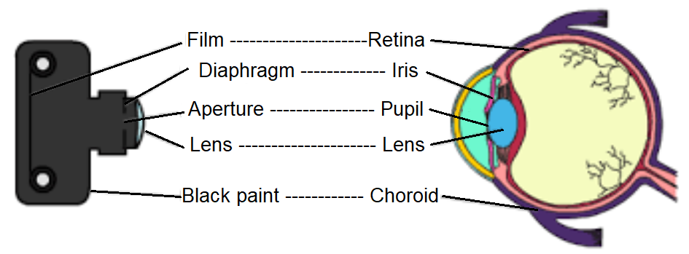

*The Analogy between the*

*eye and the camera*

As light enters the pupil, the iris reflexively regulates the amount of light by controlling the size of the pupil with its smooth muscles. The lens is capable of accommodation, that is, it changes its shape (and thereby its optical power) to adapt to the varying distance of an object, in order to maintain focus. The change in shape of the lens is regulated by ciliary muscles. Light coming from an object forms a focused image on the retina, which is smaller in size and inverted in relation to the actual object.

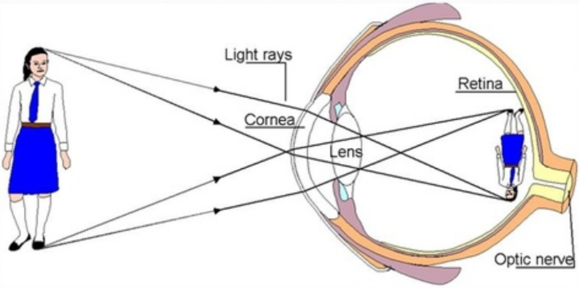

*Image formation on the Retina*

**Pathology**

There are many disorders and pathological changes affecting the eye and its components. The most important age-related changes of the eye are **presbyopia**- the gradual loss of accommodation (ability to focus),and **cataract**- formation of a cloudy area in the lens that obscures vision.

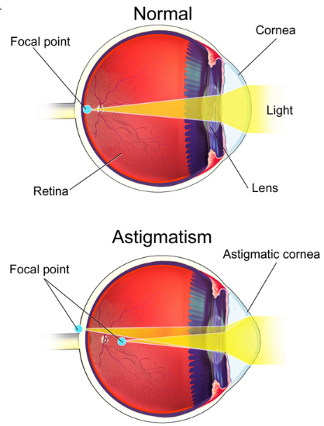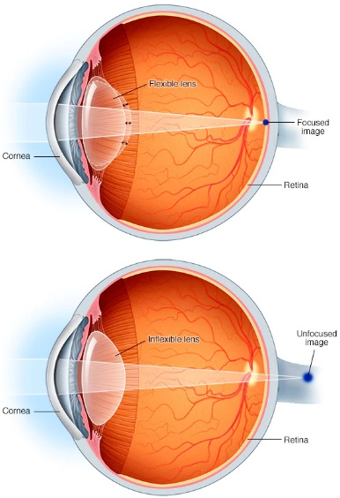Also common are myopia (near-sightedness), hyperopia (far-sightedness) and astigmatism. In astigmatism, light is not focused evenly on the retina, resulting in distorted or blurred vision. The cause is abnormal corneal curvature (abnormal shape of cornea). Near-sightedness, far-sightedness, astigmatism, and presbyopia are the most common types of **refractive error** - improper focusing of light on the retina due to the shape of the components of the eye. Cataracts are most commonly due to ageing; half of all people above the age of 75 have cataracts, currently there are around 25 million people with cataract in the US. They are responsible for half of all blindness cases worldwide and 30% of visual impairments. Both cataract and presbyopia typically develop above the age of 40, and in case of presbyopia, around quarter of all people worldwide are affected.

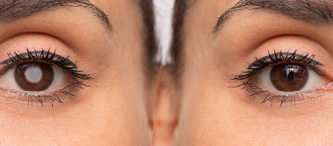

*Cataract Presbyopia Astigmatism*

**Cataract surgery**

During cataract surgery, the clouded lens of the eye is removed and replaced with an artificial intraocular lens (IOL). Phacoemulsification is the most common method of lens removal, in which the lens is emulsified using ultrasound and subsequently aspirated from the eye. Cataract surgeries are very common (around 2 million performed in the US each year), with rare complications. They are normally outpatient, done using local anesthesia, and with a short postoperative recovery period. Their efficacy and patient satisfaction are high- 90% of patients achieve a corrected vision of 20/40 or better. The most common complication following cataract surgery is posterior capsular opacification (formation of a cloudy layer of scar tissue behind the lens implant).

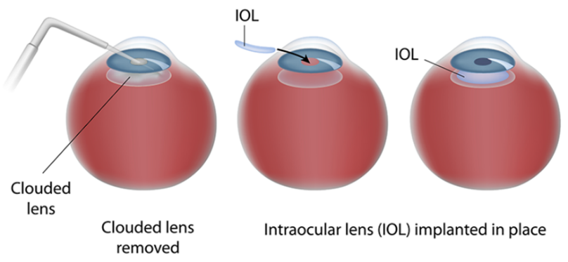

*Cataract surgery*

**Intraocular lenses**

IOLs provide the same ability of focusing as the natural lens, however (apart from newer adaptive IOLs) they cannot accommodate. They can be designed as **monofocal** (focusing light for far or near vision), **bifocal** (matched to distance and near vision), or **trifocal** (dividing light into 3 parts and providing near, distance and intermediate vision). Monofocal lenses are standard ones and most commonly implanted, with patients usually choosing far distance. Trifocal are the most recent lenses incorporating most advanced technology.

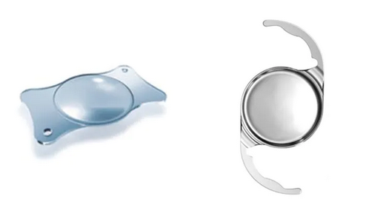

*Intraocular lenses*

Monofocal and bifocal lenses require the use of glasses; trifocal are less dependent on glasses but have a much higher incidence of undesirable photic phenomena, which is their most important drawback. Photic and adverse phenomena are 3.5 times more likely with multifocal than monofocal IOLs. They occur in low light conditions and include glare, halos, starbursts, as well as a loss of contrast sensitivity. Another inherent complication of multifocal (bifocal and trifocal) lenses is the alteration of vision physiology, coming from the introduction of additional focal points, which is non-existent in nature. As the natural lens is designed to have a single focus and accommodate according to the actual distance of the object, a multifocal lens forces the process of neuroadaptation of the brain due to light dispersion. A patient may need up to 6 months to get accustomed to seeing through a multifocal lens.

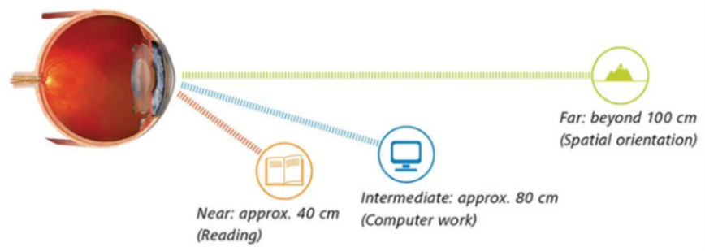

*Functionally relevant focal distances*

A special type of monofocal IOL is the **toric** lens whose shape is designed to rectify corneal astigmatism. Another type is an **aspheric** IOL which corrects for spherical aberration and improves contrast sensitivity and general vision quality, especially at night. Depending on the physical phenomena that lens design utilizes, lenses can be **refractive** and **diffractive**. Refractive are usually characterized by poorer near vision and loss of contrast sensitivity, while diffractive have poorer intermediate vision and a high potential of producing halos and glare. Most recently, innovative attempts have been made to produce **IOLs capable of accommodation** **(AIOLs)**, which face many challenges. Finally, based on the anatomic placement of IOLs, they can be subdivided into those placed in the **anterior** and **posterior chamber**. Anterior chamber lenses are placed in front of the iris, while posterior ones are placed behind it.

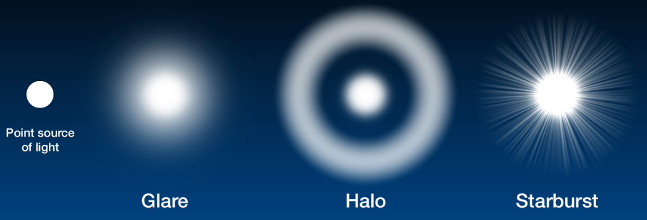

*Adverse visual phenomena associated with multifocal IOLs*

**Regulations**

As with other medical devices, clinical investigations with IOLs must be performed in accordance with **ISO 14155**, **EU Medical Device Regulation 2017/745** (which repeals Directive 93/42/EEC concerning medical devices, and Directive 90/385/EEC concerning active implantable medical devices, on 26 May 2021), **declaration of Helsinki**, as well as the local and national applicable regulations. Also, more recently, requirements for the Chinese market are becoming relevant, from the **National Medical Products Administration (NMPA)**.

Regarding pre-clinical testing, **ISO 11979-5:2020** (ophthalmic implants- intraocular lenses- part 5: biocompatibility) specifies particular requirements for the biocompatibility evaluation of IOL materials, which include evaluation of physicochemical properties. With regards to clinical testing, **ISO 11979-7:2018** (ophthalmic implants- intraocular lenses- part 7: clinical investigations of intraocular lenses for the correction of aphakia) provides general requirements for the conduct of trials with IOLs. These requirements include aspects such as: characteristics to be studied, conditions in which bilateral IOL implantation is allowed, specific requirements depending on the type of IOL, maximum and minimum number of adverse event cases, conditions for visual acuity testing (including charts, illumination, distances etc) and importantly the performance criterion of achieving postoperative monocular corrected distance visual acuity (CDVA) of 0.3 LogMAR or better.

Other parts of ISO 11979 specify further aspects such as optical and mechanical properties, labelling and shelf-life, reflecting how heavily regulated the IOL area of medical devices is.

**Subject population and trial objectives**

Implantation of IOLs is primarily intended for people who are 45 years of age or older, with significant age-related cataract or presbyopia. Some of the typical exclusion criteria are: CDVA better than 0.3 LogMAR, additional eye pathologies or pharmacotherapy that may affect the implantation of the IOL or postoperative vision, previous eye surgeries, and pregnancy or lactation.

Typical trial objectives include the fulfillment of regulatory requirements (e.g. with respect to the criterion of CDVA of 0.3 LogMAR), demonstration of various effectiveness and safety parameters of a lens, as well as comparison of a lens to other lenses on the market.

**Trial schedule and examinations**

Typically, in case of prospective studies, investigators screen patients from their lists of scheduled cataract surgeries and a screening visit is scheduled within 3 months prior to surgery. After surgery, follow-up examinations are scheduled e.g. at 6 and 12 months postoperatively. There are also standard-of-care visits between surgery and follow-up visits, as per site’s standard-of-care practice, as well as unscheduled follow-up visits as required. A list of common examinations performed at the preoperative visit, surgery and the postoperative visit is given below.

*Common examinations (effectiveness and safety endpoints)*

|  |
| --- |
| **Preoperative visit** (e.g. retrospective data collection) |
| Objective and subjective refraction |
| Monocular Distance, Intermediate and Near Visual Acuity |
| Biometry |
| Endothelial cell count |
| Slit lamp examination |
| Intraocular pressure (IOP) |

|  |
| --- |
| **Surgery** |
| Surgery Date |
| Used IOL Power Calculation Formula |
| Predicted residual refraction (D) (given by calculator) |
| Targeted refraction (D) (intended by the surgeon) |
| Targeted Surgically Induced Astigmatism (SIA) |
| Implanted IOL Power, model and serial number |
| Incision size (mm) |
| Used Injector, used Ophthalmic Viscosurgical Device |

|  |  |
| --- | --- |
| **Postoperative visit** | |
| Objective and subjective refraction | Slit lamp examination (corneal status, cataract status, inflammatory reaction, fundus examination including macula and retina)* |
| Monocular Distance, Intermediate and Near Visual Acuity | IOL status (tilt, dislocation, centration and opacity)* |
| Patient Questionnaire | PCO Assessment* |
| Pupil size (photopic and mesopic) | Intraocular pressure (IOP)* |
| Contrast Sensitivity (photopic, mesopic w/ and w/o glare) | Relevant concomitant treatments* |
| Biometry* | Secondary surgery* |
| Endothelial cell count* | Adverse Events, Device Deficiencies* |

*safety parameters

**Visual Acuity**

**Visual acuity** is the sharpness or clarity of vision, i.e. the ability to discern details. It is only one component of the overall vision ability, which also includes e.g. peripheral vision, eye coordination, focusing ability and color vision.

It can be measured as **corrected** (with glasses or contact lenses) and **uncorrected** (naked eye). It can also be measured as monocular (only one eye) or binocular (both eyes), and at different distances: **far** (distance), **intermediate** and **near** (recommended corresponding testing distances are 40 cm, 80 cm and 400 cm). Finally, it can be measured in different light conditions: **photopic** (well-lit), **scotopic** (low light, objects appear as black and white) and **mesopic** (combination of both, e.g. in street lighting conditions).

For the measurement of visual acuity in research, typically used is the LogMAR, as well as the ETDRS chart, a type of LogMAR chart which uses Sloan letters. Standard or normal vision is arbitrarily set at 20/20 or 0 LogMAR. Positive values on the LogMAR chart indicate poor vision, while negative values indicate vision that is better than normal. 20/20 (6/6 in the metric system) refers to normal vision at the distance of 20 feet. LogMAR refers to the Logarithm of the Minimum Angle of Resolution and it is one of the units of visual acuity. An observer who has LogMAR 0 can resolve letters as small as 1 minute of visual angle.

For example, 20/40 (or 0.30 LogMAR) is poorer vision and would mean that an observer must be at the distance of 20 feet to see what a person with normal vision sees at 40 feet (or can resolve only larger letters, in this case of the size of 2 minutes of visual angle). The actual formula for LogMAR calculation is somewhat more complicated and factors in the number of letters of a particular 5-letter row that can be resolved. In addition, often a decimal scale is used, on which 1.00 referes to the normal vision and values subsequently decrease for poorer vision.

|  |  |  |  |
| --- | --- | --- | --- |
| **Foot** | **Decimal** | **LogMAR** | |
| 20/200 | 0.10 | 1.00 | |
| 20/160 | 0.125 | 0.90 | |
| 20/125 | 0.16 | 0.80 | |
| 20/100 | 0.20 | 0.70 | |
| 20/80 | 0.25 | 0.60 |
| 20/63 | 0.32 | 0.50 |
| 20/50 | 0.40 | 0.40 |
| 20/40 | 0.50 | 0.30 this or better needed for IOLs |
| 20/32 | 0.63 | 0.20 (ISO 11979-7:2018) |
| 20/25 | 0.80 | 0.10 |
| 20/20 | 1.00 | 0.00 normal vision |
| 20/16 | 1.25 | −0.10 |
| 20/12.5 | 1.60 | −0.20 better than |
| 20/10 | 2.00 | −0.30 normal |

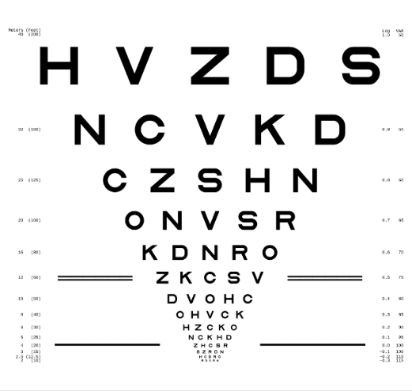

*ETDRS (LogMAR) chart and visual acuity scale*

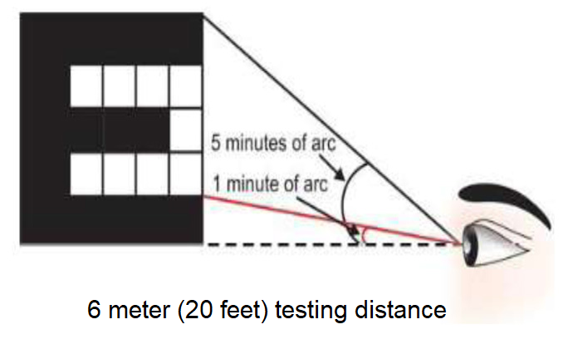

*Dimensions of a letter (in minutes of visual angle) that needs to be resolved for 20/20 vision*

**Refraction** **and optical power**

Refraction is the change in direction of a wave (llight, sound, etc) passing from one medium to another (e.g. air to optical lens). **Objective refraction** is measured using an instrument (retinoscope) while **subjective refraction** requires cooperation between the patient and the examiner. A refraction test is used to determine refractive error and the combination of lenses needed to provide the best corrected visual acuity (BCVA). Components of refraction include **sphere, cylinder and axis**. Sphere is the amount of lens power needed to correct shortsightedness or longsightedness. Cylinder is the amount of lens power required to correct astigmatism. Axis indicates the angle at which lens correction (cylinder) needs to be placed in the lens. Sphere and cylinder are measured in diopters and axis in degrees. The notation of these values (+ or - sign) is somewhat arbitrary depending on the clinical site and is usually pre-determined by the sponsor. Often calculated is the **spherical equivalent**, by merging the spherical and cylindrical components of refractive error, and is equal to the sum of sphere and 1/2 of the cylinder.

Therefore, although a LogMAR chart is used in both cases, visual acuity is determined for a particular distance and produces a LogMAR value, whereas refraction gives information on how to precisely correct refractive error, via three different outputs. Conversely, visual acuity is assessed by simply looking at the LogMAR chart, while the diagnosis of refractive error requires using a number of lenses of different optical powers. Cycloplegic agents are often used to paralyze the ciliary muscle (preventing accommodation) in order to more accurately determine the true refractive error of the eye.

**Optical power (P)** is the degree to which a lens converges or diverges light, and it is equal to the reciprocal of the focal length (f) measured in meters (P = 1/f). The unit of measurement of the optical power is diopter (D). Focal length is the distance from the lens to the focal point (focus). In the natural eye, optical power is realized by the curvature of the cornea and the lens. Cornea amounts to two-thirds of the eye's total optical power (40 diopters), and the lens for the remaining one third (20 diopters).

The **focal length** of a lens is determined by its refractive index and its curvature. Refractive index (n) refers to how fast light travels through a medium (n= c/v, where c is the speed of light in vacuum and v is the speed of light in the medium). Therefore, considering the abovementioned definition of refraction, refractive index determines how much the path of light is refracted (bent), when entering a material (e.g. a lens).

A specific optical power and refractive index are characteristics of every IOL.

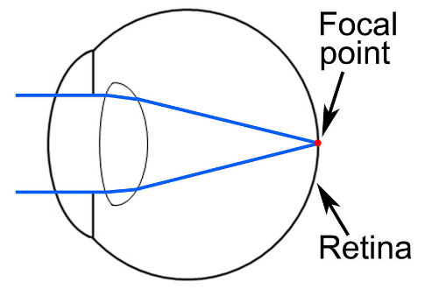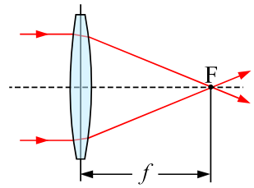

*Focal length (f) and focal*

*point (F)*

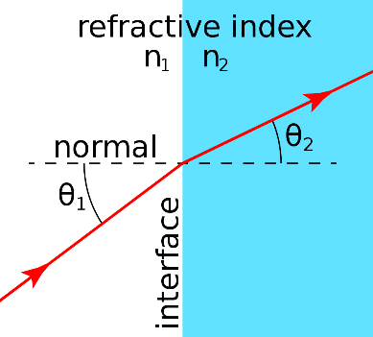

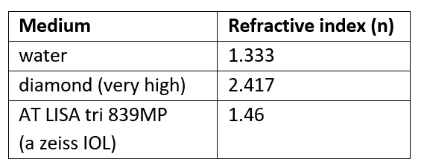

*Refractive index* (n)

**Contrast Sensitivity**

Contrast sensitivity is the ability to discern between different levels of luminance (in simplified terms- the amount of light) in a static image, i.e. to distinguish its bright and dim components. Measurement of the contrast sensitivity complements the measurement of visual acuity. Lower contrast sensitivity may cause decreased visual function in spite of normal visual acuity. For example, a person many have 20/20 vision but struggle with activities such as driving at night, because of poor contrast sensitivity.

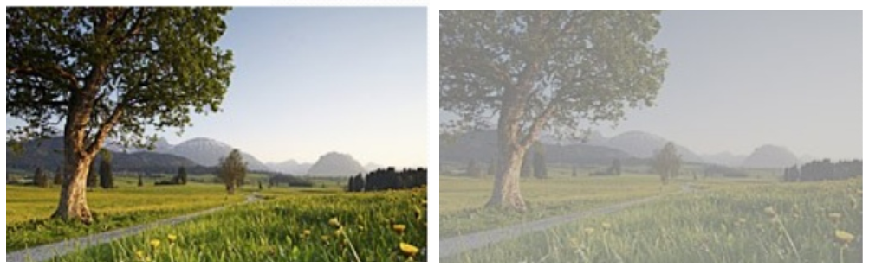

*Image to the left has higher contrast*

**The contrast sensitivity function** assesses sensitivity over a wide range of spatial frequencies, while visual acuity measures primarily sensitivity at the high spatial frequencies. The reason why visual acuity measures sensitivity largely in the higher frequency regions of the contrast sensitivity function is because it is evaluated in terms of the smallest identifiable, high-contrast target (black letters of decreasing size on a white background), and because small sizes correspond to high spatial frequencies. The spatial frequencies necessary for correct detection of small letters are in the range from 18 to 30 cpd (cycles per degree), so those less than 18 need to be evaluated by contrast sensitivity.

Contrast sensitivity is typically measured at spatial frequencies of 1.5 cpd, 3 cpd, 6 cpd, 12 cpd and 18 cpd, monocularly on the dominant eye. Results are presented in LogMAR units for each frequency, often as a graph with contrast threshold on the vertical axis and spatial frequency on the horizontal axis. Contrast sensitivity reaches a maximum at frequencies of 2-5 cpd. **Contrast threshold** represents the smallest amount of contrast required to be able to see the target.

In a contrast sensitivity exam, instead of a LogMAR chart, the Pelli-Robson chart may be used, which consists of uniform-sized but increasingly pale grey letters on a white background. Also, sine-wave gratings (parallel bars of varying width and contrast), or related FACT (Functional acuity contrast testing) charts are often used. Regarding sine-wave gratings, the width of the bars and their distance apart represent spacial frequency.

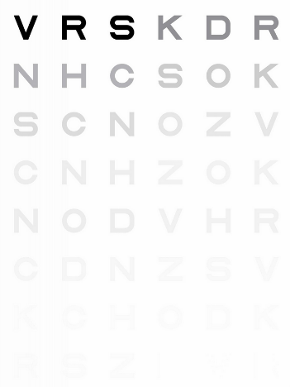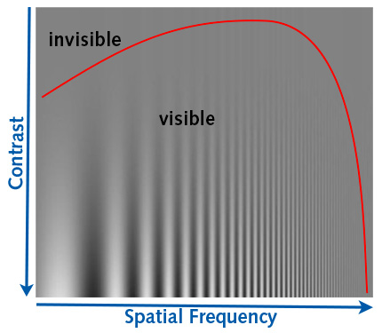

*The graph of contrast sensitivity function*  *Pelli-Robson contrast sensitivity chart*

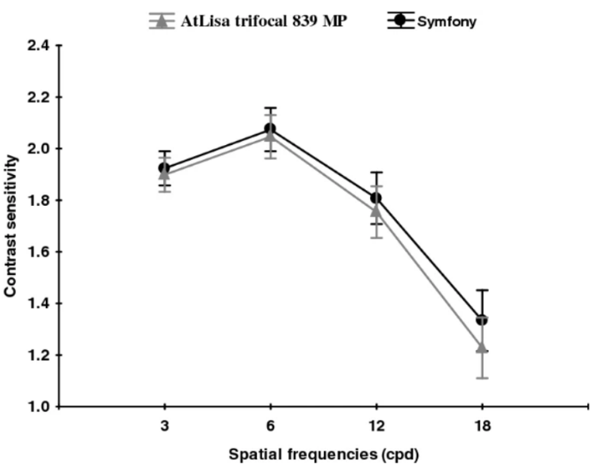

*Contrast sensitivity comparison in*

*photopic conditions between two IOLs*

**Defocus curve**

A defocus curve offers a controlled way of measuring a patient’s visual acuity with varying levels of defocus. Instead of evaluating visual acuity at various distances, a series of lenses are presented in front of a patient’s eye and the degree of induced “defocus” is measured. Visual acuity is usually measured in the range of +1.00D to -4.00D, using 0.50D increments. In doing so, the measured acuity simulates what the patient’s visual acuity would be at different distances i.e. provides an objective measure of expected vision at different distances. For example, a -1D lens is optically equivalent to 1m viewing distance, a -2.50D lens represents 40cm, and -4D for 25cm.

X axis of the defocus curve is induced defocus in diopters, and on Y axis is visual acuity, e.g. in LogMAR. The results for a single patient can be plotted, or the results for a group of patients can be averaged and plotted.

Therefore, a defocus curve is used to measure the range of achieved focus, usually in order to assess the performance of presbyopia-correcting IOLs and compare different multifocal technologies. A comparison of defocus curves for a bifocal and trifocal lens shows the typical valley in the intermediate range (-0.5D to -2D) for the bifocal lens, whereas for the trifocal lens the curve is much flatter, showing good intermediate visual acuity and a smooth transition from near to distance vision.

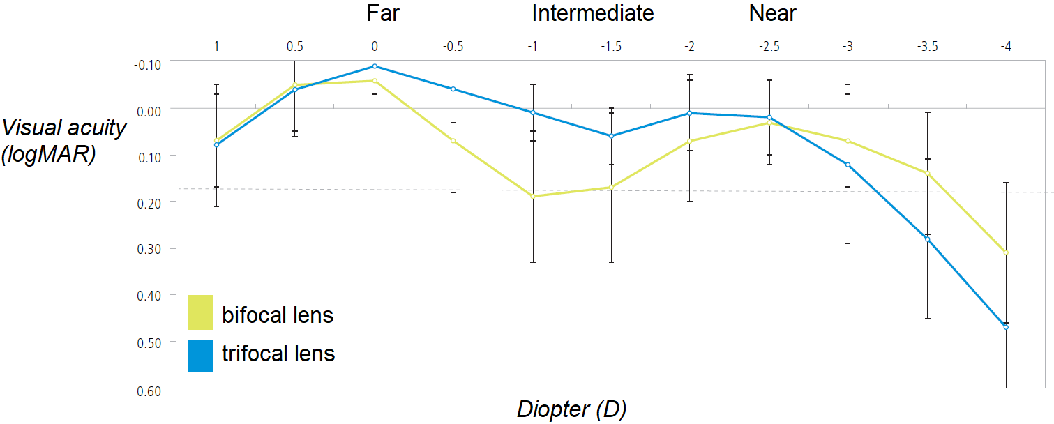

*Defocus curves for a bifocal and trifocal lens*

**Biometry, slit lamp examination and safety aspects**

**Biometry** is the process of measuring the power of the cornea (keratometry) and the length of the eye, and using this data to determine the ideal intraocular lens power. The curvature of the anterior surface of the cornea is measured using an instrument called keratometer and it determines corneal power. This provides information on the degree of corneal astigmatism and presence of any corneal distortion. The same values can be obtained with the IOL Master, which also measures parameters such as anterior chamber depth.

Important biometry parameters are values such as corneal radii (steepest and flattest radius) and axes (together describing the curvature of the cornea), as well as the axial length. The **axial length** is the distance between the anterior surface of the cornea and the retina (fovea). Radii, axial length and anterior chamber depth are measured in mm, and axis values in degrees. The axial length and corneal power, along with the A-constant (anterior chamber constant, which estimates the postoperative lens position) are values required for intraocular lens power calculation. **IOL** **power calculation** must be accurately done to provide an IOL that fits the specific needs of the individual patient.

A **slit lamp examination** comprises the safety biomicroscopy evaluation of the anterior structures of the eye such as the eyelid, conjunctiva, iris, anterior chamber, as well as the posterior structures (fundus). It may diagnose conditions such as macular degeneration, detached retina, cataracts, corneal injury, blood vessel blockage, increased eye pressure, infection, etc.

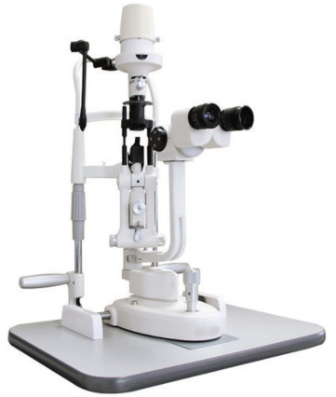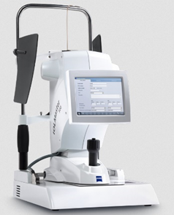

*IOL Master 500 Slit lamp*

The **fundus** of the eye is the interior surface of the eye opposite the lens and includes the retina, optic disc, macula, fovea, and posterior pole. As mentioned, macula is responsible for the central, high-resolution color vision in good light. The rest of the retina processes peripheral, or side vision. **Fovea** is located in the center of macula and provides the greatest visual acuity (highest concentration of photoreceptors). The point of exit of retinal axons from the eye is called the optic disc, which corresponds to a small blind spot in each eye.

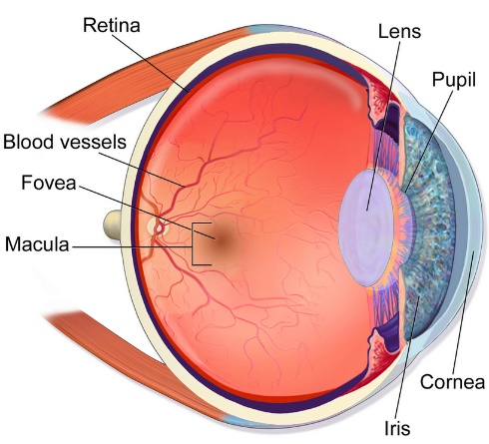

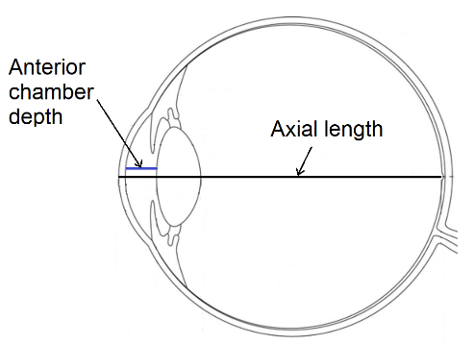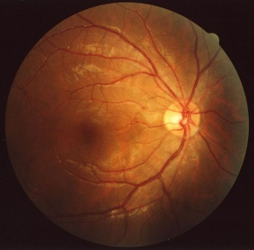

*Axial length and anterior chamber depth Macula and fovea Fundus with the optic disc*

Additional safety assessments include the measurement of the possible **IOL decentration and tilt, intraocular pressure (IOP), endothelial cell count** (corneal cells), and detection of **posterior capsule opacification (PCO)**. IOL decentration and tilt refer to the mispositioning of the implanted lens, which can cause the deterioration of retinal image quality. As mentioned, PCO is the most common postoperative complication of cataract surgery in which the posterior capsule undergoes secondary opacification due to the migration, proliferation, and differentiation of lens epithelial cells. Posterior capsule is a clear, membrane-like structure synthesized by the lens epithelial cells to encapsulate the lens fibers. Opacification can cause considerable visual symptoms, but is easily handled with a laser treatment (Nd:YAG capsulotomy). A PCO which is not very pronounced and does not require surgery is not considered to be an adverse event.

Also, regularly measured is pupil size in different lighting conditions, and patients are administered a questionnaire, which among other aspects assesses the presence of unwanted visual phenomena (halos, glare, starburst), that are often associated with IOLs, particularly in night-time conditions.